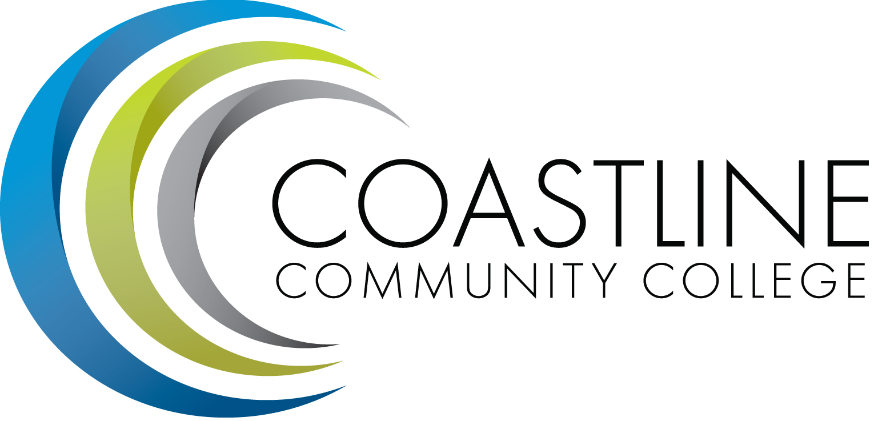
Coastline Management Meeting (CMT) Agenda
May 1, 2018, 9:00 – 11:00 a.m.
College Center – 4th Floor Conference Room

Committee Mandate: To review and improve College operations and management through sharing information, discussion, and staff development.

CALL TO ORDER
  - Welcome
  - Adoption of Agenda
  - *Approval of Minutes – February 6, 2018

REPORTS & UPDATES (15 minutes per)
  - District Wide Strategic Plan 2014-17 Evaluation Summary – Dr. Andreea Serban, Vice Chancellor, Educational Services and Technology (20 Minutes)
  - District Wide Strategic Plan 2018-21 Draft – Dr. Andreea Serban (20 Minutes)
  - Executive Team Update (Adrian, Groot, Mueller, Nguyen, Rodriguez)
  - ASG (N. Brais)
  - Academic Senate (S. Barnes)
  - Classified Senate ( K. Donahue)

CLOSING THE LOOP – FOLLOW UP ACTIONS

PLANNING/DISCUSSION
  - 2018 Fall Flex – August 24, 2018 (S. Blair)
  - *Participatory Governance Document (L. Adrian)
  - *Financial Aid Fraud (K. Mueller)
  - Professional Development Events & Funding (S. Blair, R. Akins)
  - Upcoming A2I2 Guided Pathways Visit – May 8 (L. Adrian)

- PROFESSIONAL DEVELOPMENT
  - Manager’s Retreat – June 18-19, Irvine Marriott (L. Adrian)
    - Appreciative Inquiry
    - Emotional Intelligence
    - Planning for 2018-19
  - Guided Pathways with Kathy Obear (L. Adrian)
    - July 10-11 – Classified Professionals
    - August 23 – Faculty

- ANNOUNCEMENTS

- CLOSED SESSION

- ADJOURNMENT
*Attachment
Next Meeting: June 5, 2018

